MANCHESTER AND DISTRICT WALKERS (MR50)

COMMITTEE MEETING

24th September 2025, 18.30

AGENDA AND REPORTS

Agenda item | Requested by
- Welcome | ES
- Apologies | LE
- Acceptance of minutes from previous meeting. | All
- Young Ramblers Weekend.  Costs | ES / M
- AGM  Update on AGM 2025 planning/costs – Lottie  Update on AGM 2024 raffle winners – should we issue a deadline?  Final reports due – Friday 10th October  Advertising roles/ duties | EC
- Christmas Social Planning ?
- Feedback from Survey

- potential wording change on sign up form for walks (based on whatsapp chat messages)
- - Behaviour on walks - reflection on behaviour on walks/MAD events this year

Outstanding actions from last meeting:
Next of Kin info
Action RP/ES to agree process for inputting next of kin on a form and what we would then do with that information.
Action KC to do a pinned Instagram post and facebook (public) post/document clarifying walk ratings for new walkers ONGOING

Walk sign-ups – to remove sign up forms for unlimited walks?
Decision to keep and add a tick box asking whether attendees have ICE info on them/provide link to what is ICE info ACTION WMs
Monthly Social attendance– in opening paragraph on social page, improve sentence to specify/improve location of social and holding dates for future socials – ACTION CC, WMs

Walk feedback form – EC suggest to send out link for feedback form to get data about why new members join or don’t join/come back. Results to go to committee. ACTION EC

Ongoing Actions
Action / Description

REPORTS

Chair (Ellie)
Hello MAD walkers,
Summer is no longer here, but we keep on walking!
Updates from me include:
o Young Ramblers Weekend is being held in Manchester from Friday 24th to Sunday 26th October. Plans are almost finalised and we are expecting at least 60 other young ramblers!
o MAD members are welcome at walks and events but for paid events, priority will be given to members who have helped or volunteered on the weekend.
o We are still looking for volunteers for:
- Helping meet and greet on Friday
- Lead walks on the Saturday
- Help at social on the Saturday evening
- Lead short Manchester-based walks on Sunday
o It is almost time for the AGM again (how did that happen?) – this is being held on Saturday 15th November (15:00) at the Ape and Apple (John Dalton Street). All members are welcome to join!

Secretary (Lottie)
I’ve booked the AGM venue, for the 15th November. Same location as last year.

Walks Co Ordinator (Mike & Kim)
There’s been lots going on as always. As part of Ramblers rollout of their training program they have put together an in person training workshop. After contacting the people who need to complete their training to gauge interest, I am planning to deliver this in the next few weeks, pending confirmation from the venue at Manchester University. This is a little trickier to organise than other meetings due to the requirement of a screen to deliver the session.
Planning for the National Young Ramblers weekend is progressing well with a great variety of walks for people to choose from across both days. Massive thanks to everyone who has got on board to help out leading walks across the weekend. Along with the social activities which are being planned it is shaping up to be a brilliant event.
Dominic Davies led his first walk for the group, while Tim Drayton and Scott Doherty are planning to lead their first walks over the next few weeks. This brings the total of new walk leaders to 10 over the course of the year, averaging around 1 a month consistently. It is great to see so many people stepping forward to take the group forward.
Tom Scarborough has led the most walks over the last two months, and due to a cancellation ended up leading all the walks one weekend, a fantastic effort. More widely, there have been 30 walks led by 20 different leaders. 37% were rated as Moderate and 90% were accessible by Public Transport. Saturday remains the most popular day, with only 2 walks on weekdays as the evenings draw in. According to the walk descriptions, we have walked a total of 341 miles and 15036 meters of ascent.

Membership Secretary (James)
According to the Ramblers Membership Insight Hub, as of 23/09/2025 we have 654 members. Since 23/06/2025 there have been 43 new members and 3 are showing as having re-joined.
The are currently 365 members of the MAD Walkers Members Facebook group (up from 358 at the time of my July report). I have given notice today of another membership check, allowing people the chance to re-join if necessary.
I’ve sent another email today using Mailchimp to everyone who signed up for our walks and indicated on the form that they were not a member since my last Mailchimp email. Some had already joined when I cross-checked their names against the list of members, which is encouraging.
Another use I have made of Mailchimp was to send the Membership Survey ink on Ed Cooper’s behalf. This achieved over 55% of recipients opening it and around a sixth clicked on the link contained within the email. Several people reported on the Facebook group that they never received the email, which still needs looking at to improve communications with the membership.

Treasurer (Natalie)
Treasurer (Natalie)

See below extract from the accounts updated 22/09/2025. The total currently stands as £9,724.38
N.B: This includes a balance of £1,068.40 that is ringfenced solely for the use of the Young Ramblers Weekend. This amount will need to be transferred to the Ramblers group that organises the next one after us.

Key transactional activity since the last committee meeting includes:
- Summer BBQ Social - now all complete
- Glencoe Weekend (25th - 29th Sep) - ongoing
- South West Ireland Weekend (17th - 20th Oct) - ongoing
- New Years Llanberis Weekend - ongoing - sign ups now open

Looking ahead, we will continue to expect significant activity against the 3 weekends above, as well as transactions for the AGM 2025 and Young Ramblers Weekend. In addition, I am currently preparing the annual return that is due mid October.

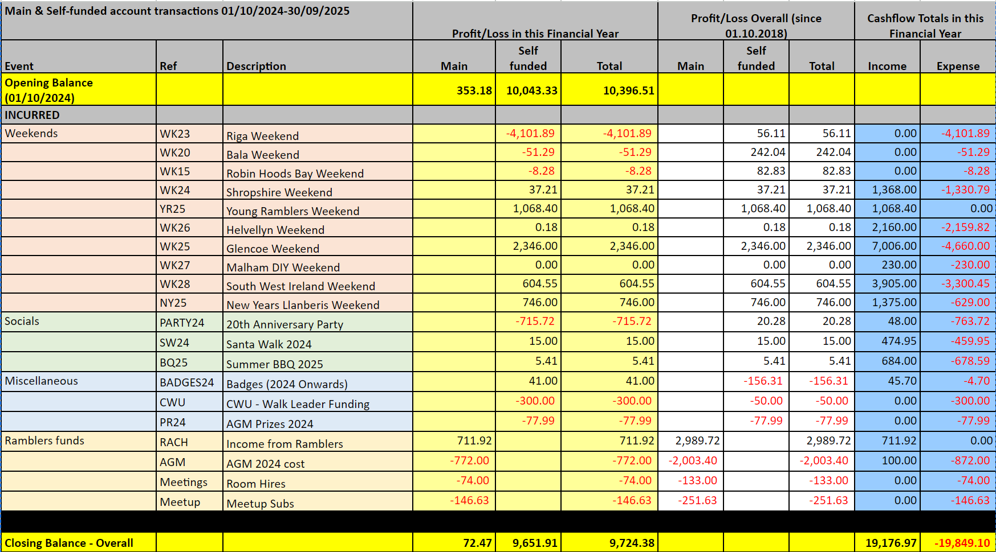

Social Secretary (Chip)
We have been busy planning the Young Ramblers Weekend.
Thanks for those who attended the summer BBQ, I think you will all agree it was a great success.

Thanks,
Chip

Communications And Social Media (Katie and Ed)
In September we launched the MAD Walkers members feedback survey. 62 responses have been received so far, which is excellent uptake.
Katie has been super busy helping to organise the Young Ramblers Weekend.

Webmaster (Desi and Rob)
Hello,
Here's our report for the last period:
There were changes done in the way linear and circular logic works, when showing the walks on the website. This should resolve the occasional instances of linear walks being shown as circular and vise versa.
Website information about weekends has been updated with more links. In the walks page Sunday stroll details were added and the statement saying "no need to book" has been removed. Walk leaders instructions were updated with the ICE details recommendations.
Best regards,
Desi and Rob

Weekends Co Ordinator (Miranda)
Upcoming
Two hostel weekends are on the calendar:
Glencoe September 2025 - Jess Booth
Llanberis New Year 25/26 - Me and John Bailey

